

**Proposal Cover Sheet**

**Term: Fall_x____ Spring _____ Year _2011_____**

**Instructor ______Nora E. Demers____________**

Name: ____Steven M. Blackburn______________________________________

Present Year in Education (e.g., freshman, sophomore, etc.): ______ Junior______________

E-mail Address: __________blackbst@comcast.net________________________

Major ___________Biotechnology___________________________

Have you identified a research mentor for a senior thesis (if applicable)?

_____ Yes __x___ No.

If yes, please identify.

Name: _________N. A. _________________________________

**Title of Proposal:**

___Gene expression analysis of rats treated with experimental Acetyl CoA Carboxylase inhibitors will show interactions with the peroxisome proliferator activated receptor beta pathway.________________________________________________________________________

___________________________________________________________________________

**Checklist:**

All required portions of the first submission are included ___x__ Yes _____ No

I had an external reviewer read the proposal __x___ Yes _____ No

If Yes, who ________________________________________ When _______________

I authorize the use of this proposal as an example in future courses ___x__ Yes _____ No

**Abstract**

The problem being addressed by this research is a lack of knowledge on how two experimental molecular inhibitors of Acetyl CoA Carboxylase affects the peroxisome proliferator-activated receptor beta pathway. The objective of the proposed research is to determine whether the two experimental Acetyl CoA Carboxylase inhibitors A-908292 (S) and its enantiomer A-875400 (R) regulate the expression of genes involved in the peroxisome proliferator-activated receptor beta pathway in the liver of rats. A microarray analysis of rat genes will be used to determine whether the gene expression in the PPAR beta pathway is significantly regulated by the experimental inhibitors. The results of this research may have implications for advancing science in biology. If a statistical analysis reveals that there is regulation of gene expression caused by the inhibitors, then the fat storage on non-adipose tissue i.e. the liver, will be a function of the dose amount of the inhibitor prescribed( The PPAR beta pathway regulates fat storage in non-adipose tissue).

**Table of Contents**

Table of Contents 3.

Project Description

a. Problem Statement 4.

b. Research Objective 6.

c. Methods 6.

d. Timetable and Project Management 13.

e. Significance of Expected Results 13.

f. Equipment and Special Resource Needs 14.

References Cited 15.

Biographical Sketch 16.

Response to peer reviews

**Project Description**

a. Problem Statement

Microarrays help in proposing mechanisms for pharmacological agents in vivo (Waring et al., 2005). My research will this use gene expression analysis technology to reveal if there is any interaction of two experimental Acetyl CoA Carboxylase inhibitors A-908292 (S) and its enantiomer A-875400 (R) on the peroxisome proliferator-activated receptor beta pathway.

Pharmacological agents can sometimes unintentionally affect certain biological pathways (Waring et. al., 2005). In one study, an experimental drug turned out to be an agonist in the peroxisome proliferator-activated receptor alpha pathway even though the primary purpose of the drug was to affect a pathway that would inhibit Acetyl-CoA Carboxylase from being synthesized (Waring et. al., 2008). The inhibition of Acetyl CoA Carboxylase supports the oxidative and catabolic reactions involved in breaking down fatty acids (Ruderman and Prentki, 2004). Low concentrations of Acetyl-CoA Carboxylase in mice show a favorable metabolic profile; the mice are resistant to high-fat diet-induced obesity and show decreased lipid content in the liver (Oh et al., 2005).The PPAR alpha pathway also functions to breakdown fat in the liver and other non-adipose tissue. It is a transcription factor that is activated by fatty acids and pharmacological agents (Grundy and Vega 1987). If Waring et al. hadn’t performed a gene expression analysis using microarray technology; they might have erroneously concluded that the experimental A-908292 (S) and its enantiomer A-875400 (R) were reducing fat storage through the Acetyl CoA-Carboxylase pathway. It was the use of microarray technology that allowed the researchers to see which genes were up or down regulated after treatment of experimental A-908292 (S) and A-875400 (R).

I intend to take the study on PPAR pathways further. I will test if A-908292 (S) and A-875400 (R) are involved in the PPAR beta pathway. Gene expression analysis via microarray technology should provide results indicating whether or not the two drugs cause up or down regulation for the genes involved in the PPAR beta pathway. If the results indicate these two drugs cause up regulation of the PPAR beta pathway genes, then the drugs could potentially act to reduce the fat storage on the liver via the PPAR beta pathway.

b. Research Objective

The researcher intends to determine whether or not A-908292 (S) and/or A-875400 (R) causes regulation of genes involved in the PPAR beta pathway. The hypothesis is neither A-908292 (S) nor A-875400 (R) will cause significant regulation of the PPAR beta pathway.

c. Methods

Experimental Design

The purpose of this experiment is to compare gene expression profiles of Sprague-Dawley rats under different pharmacological treatment. If treatment of rats with experimental Coenzyme A Carboxylase inhibitors A-875400 (R) or A-908292 (S) yield gene profiles statistically similar to a profile caused by the beta pathway agonist Rosiglitazone, then the experimental inhibitors are causing regulation of genes in that pathway. The question that is being researched in this experiment is whether or not the two experimental inhibitors cause regulation of genes in the PPAR beta pathway similar to how Rosiglitazone regulates them. To compare the profiles requires the use of microarrays and software that analyzes statistical differences between them. Figure 4 provides a diagram comparing gene expression profiles between individual rats treated with different agents.

Data Collection

For the gene expression analysis study, Sprague-Dawley rats weighing between 201 and 221 g will be obtained from Charles River Laboratories, Inc. (Portage, MI). These rats are genetically similar between individuals of the population, and therefore make good test subjects (Waring et al. 2008). Rats will be fed a standard diet of Lab Diet Rodent Laboratory Diet 5001 pellets (PMI Nutrition International, Inc., St. Louis, MO). Rats will be dosed with A-875400 (R) (n = 3), or A-908292 (S) (n = 3) at 30 or 100 mg/kg/day for a period of 3 days. The other rats will be treated with 200 mg/kg/day with Rosiglitazone. The dose volume for all treatment groups is 4 ml/kg/dose. The statistical differences between gene expression profiles of different treatment groups are expected to be large. This is why three rats per treatment group is an acceptable size per treatment group. All rats will be fasted overnight after their last treatment and euthanized under CO2 anesthesia (Waring et al. 2008).

Livers will be collected from all rats and flash frozen in liquid nitrogen and subsequently stored at-70°C. Frozen liver samples (approximately 100 mg of tissue per sample) will be immediately added to 2 ml of TRIzol reagent (Invitrogen, Carlsbad, CA) and homogenized using a Polytron 300D homogenizer (Brinkman Instruments, Westbury, NY). One milliliter of the tissue homogenate will be transferred to a microfuge tube, and total RNA was extracted via chloroform extraction followed by nucleic acid precipitation with isopropanol. The pellet will be washed with 75% ethanol and resuspended in molecular biology grade water. Nucleic acid concentration will be determined by o.d. 260 nm (Smart-Spec;Bio-Rad Laboratories, Hercules, CA). The integrity of the RNA from the samples will be determined using an Agilent 2100 Bioanalyzer. Figure 1 provides an example comparing good RNA integrity with bad RNA integrity (Waring et al. 2008).

Microarray analysis is performed using the standard protocol provided by Affymetrix Inc. (Santa Clara, Cal). Messenger RNA will be extracted from the total RNA samples using the Qiagen Oligotex mRNA Midi Kit (Cat. No. 70042). Figure 2 provides an example of the mRNA extraction using the Midi Kit instructions. cDNA is prepared from 1 mg of messenger RNA using the Superscript Choice system from Gibco BRL LifeTechnologies (Cat. No. 18090-019). Following this, labeled cRNA is synthesized from the cDNA using the Enzo RNA Transcript Labeling Kit (Cat. No. 900182) according to the manufacturer’s instructions. Approximately 20 mg of cRNA is then fragmented in a solution of 40 mM Tris–acetate, pH 8.1, 100 mM KOAc, and 30 mM MgOAc at 94° for 35 min. Labeled cRNA is hybridized to the Affymetrix GeneChip Test2 Array to verify the quality of labeled cRNA. Following this, cRNA is hybridized to the Affymetrix Rat Toxicology U34 Array (Cat. No. 900252). The cRNA will be hybridized overnight at 45°C (Waring et al. 2001b).

Data Analysis

The microarray scanned image and intensity files (.cel files) are to be imported into Rosetta Resolver gene expression analysis software, version 5.0 (Rosetta Inpharmatics, Seattle,WA). Samples from all individual rats are hybridized to the Affymetrix RAE230A chip. Individual expression profiles from treated rats will be compared with an in silico pool of expression profiles from the vehicle-treated rats. Genes will be considered significantly regulated if the p value assigned to the gene by Resolver is less than or equal to 0.01. Data analysis will also be conducted using DrugMatrix version 3.10 (Iconix Pharmaceuticals, Mountain View, CA) (Ganter et al., 2005). The similarity of gene expression profiles of the test compound and reference compounds from the DrugMatrix database is calculated as the Pearson’s correlation coefficient based on the common genes shared by the Affymetrix RAE230A and Codelink RU1 (GE Healthcare, Piscataway, NJ). The affect on pathways is calculated as the percentage of perturbation with a p value determined by hypergeometric distribution. To detect significant gene expression changes induced by the A-908292 (S) and A-875400 (R), the gene expression ratios from rats treated at 100 mg/kg/day will be analyzed by error-weighted one-way ANOVA with Benjamini and Hochberg multiple testing correction using the Rosetta Resolver system. Probes with a false discovery rate less than or equal to 0.01 are considered statistically significant (Waring et al. 2008).

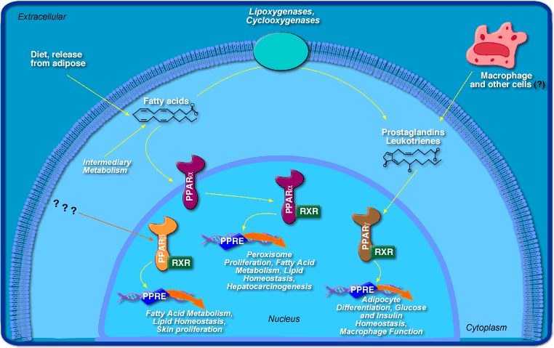

Figure 1. This figure shows a basic PPAR alpha, beta, gamma pathway.

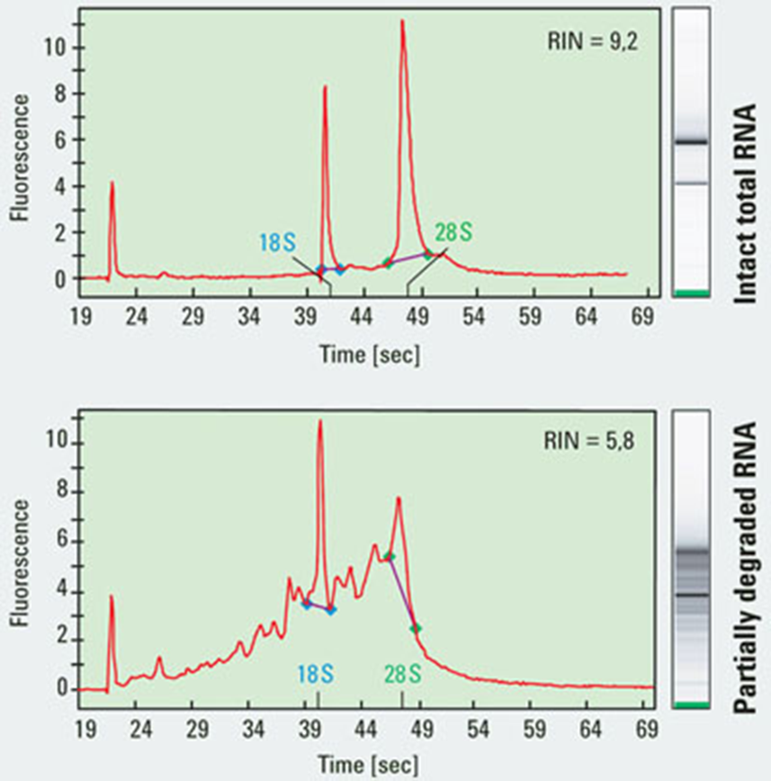

Figure 2. In the first figure, total RNA (rRNA, tRNA, mRNA etc.) is not degraded. In the second figure, the RNA has been degraded by RNAases; enzymes that denature and breakdown RNA’s.

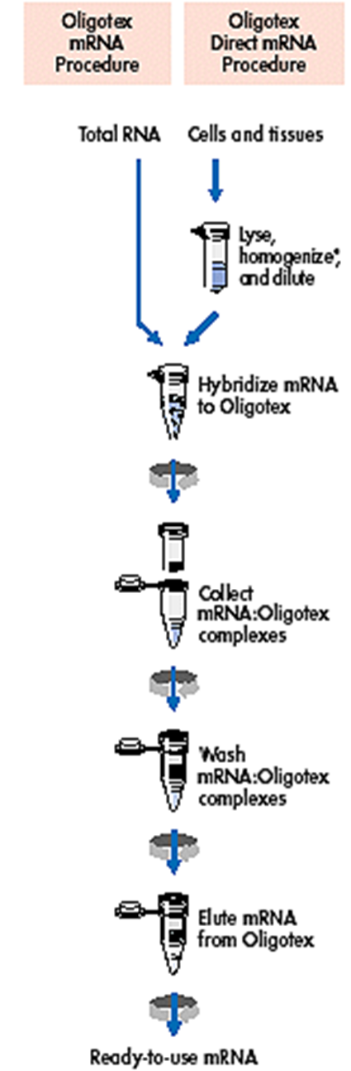

Figure 3. In this experiment, we extract mRNA by starting with the Oligotex mRNA procedure on the left, rather than the direct mRNA procedure on the right.



Figure 4. – Replace the Bez. Header with Rosiglitazone. The y-axis is a list of genes involved in the PPAR beta pathway. The A-875400 (R) and A-908292 (S) columns are compared to the Rosiglitazone column. The colors in the squares indicate the level of gene expression. Each individual column represents one rat. There are 15 rats being treated in this experiment.

d. Timetable

1. Three days to treat rats

2. One night to store rat livers at -70 degrees celcius

3. One day to perform microarray

4. One day to analyze microarray

Five days needed to complete experiment.

e. Significance of Expected Results

The results will show whether or not A-908292 (S) and/or A-875400 (R) regulates genes in the PPAR beta pathway. If there are genes up-regulated, then there should be an overall decrease in fat storage in the liver caused by A-908292 (S) and/or A-875400 (R). A different experiment would be required to determine fat storage in the liver as a function of A-908292 (S) and/or A-875400 (R) dosage. If that new experiment showed that the increased dosage of the drugs reduced fat storage, then the reduced fat storage is caused by A-908292 (S) and/or A-875400 (R) via the PPAR beta pathway. Studying fat storage without microarray analysis would not reveal a mechanism for how the fat storage on the liver was reduced by the drugs. Using the microarray reveals the genes involved, and subsequently the mechanism used.

f. Equipment and special resources

15 Sprague-Dawley rats, Charles River Laboratories, Inc. (Portage, MI) IACUC approval

Liquid Nitrogen

o.d. 260 nm (Smart-Spec;Bio-Rad Laboratories, Hercules, CA)

Agilent 2100 Bioanalyzer

Qiagen Oligotex mRNA Midi Kit (Cat. No. 70042)

Polytron 300D homogenizer (Brinkman Instruments, Westbury, NY)

Gibco BRL LifeTechnologies (Cat. No. 18090-019)

Enzo RNA Transcript Labeling Kit (Cat. No. 900182)

Affymetrix GeneChip Test2 Array

Rosetta Resolver gene expression analysis software, version 5.0 (Rosetta Inpharmatics, Seattle,WA)

**References Cited**

Grundy, S.M., Vega, G.L. (1987). Fibric acids: effects on lipids and lipoprotein metabolism. American Journal of Medicine. 83:9–20.

Oh W. Abu-Elheiga L., Kordari P., Gu Z., Shaikenov T., Chirala S.S., Wakil S.J. (2005). Glucose and fat metabolism in adipose tissue of acetyl-CoA carboxylase 2 knockout mice. Proc Natl Acad Sci USA. 102:1384–1389.

Ruderman N., Prentki M. (2004). AMP kinase and malonyl-CoA: targets for therapy of the metabolic syndrome. Nature Reviews Drug Discovery. 3:340–351.

Waring, F. J., Jolly, R.(2001). Clustering of Hepatotoxins Based on Mechanism of Toxicity Using Gene Expression Profiles. Toxicology and Applied Pharmacology. 175: 28-42.

Waring J.F., Ciurlionis R., Clampit J.E., Morgan S., Gum R.J, Jolly R.A., Kroeger P., Frost L., Trevillyan J., Zinker B.A., et al. (2005) PTP1B antisense-treated mice show regulation of genes involved in lipogenesis in liver and fat. Molecular and Cell Endocrinology. 203:155–168.

Waring, F. J., Yang, Y. (2008). Gene Expression Analysis in Rats Treated with Experimental Acetyl-Coenzyme A Carboxylase Inhibitors Suggests Interactions with the Peroxisome Proliferator-Activated Receptor Alpha Pathway. Pharmacology and Experimental Therapeutics. 324:507-516.

**Biographical Sketch**

Steven Blackburn

1457 Scenic St.

Lehigh Acres, Fl. 33936

239-247-2205

blackbst@comcast.net

*Education*

Fort Myers Senior High School: International Baccalaureate diploma recipient (2002-2006-)

Edison State College: General Associates of Arts 3.5 GPA (2009-2011)

Florida Gulf Coast University: B.S. Biotechnology 4.0 GPA (2011-in progress)

*Volunteer Work/skills*

Florida Gulf Coast University Food Forest 2011

Aquatic Systems Mosquito Control Education program (in progress) 2011

Adept at culturing eukaryotic cells. Cell biology

Fluorescent microscopy. Cell biology

Micropipetting. Cell/microbiology

Peer review response

I only made a few modifications to the final draft of the research proposal. I added a diagram that illustrates the premise of the PPAR pathways in a cell. I fixed several grammatical errors. I indented all paragraphs. I paraphrased sections and cited to avoid plagiarism.